 

**ANNA UNIVERSITY**

**MADRAS INSITITUTE OF TECHNOLOGY**

**CHROMEPET CHENNAI 600044**

**NAAN MUDHALVAN - DIGITAL MARKETING**

**PROJECT - CREATING BLOG USING WORDPRESS PLATFORM**

**DEPARTMENT - RUBBER AND PLASTICS TECHNOLOGY**

**TEAM MEMBERS:**

1. **ANGELINE(2020508006)**
2. **GOWTHAMI(2020508018)**
3. **SHARINI(2020508040) K. SIVANESH(2020508043)**

**1.1 Overview**

The student guide mit Website Project aimed to create a dynamic and user-friendly website using the WordPress platform. The goal was to design an appealing and responsive website that not only showcases compelling content but also offers a seamless user experience. The website was customized, essential plugins were configured, SEO optimization was implemented, and a user-friendly content management system was established. This WordPress blog serves as a platform to share valuable information, engage with the audience, and establish an online presence effectively.

**1.2 Purpose**

The purpose of this project is to:

* Design an aesthetically pleasing and responsive website.
* Showcase compelling content that appeals to the target audience.
* Offer a seamless user experience to website visitors.
* Customize the theme to align with the brand and content.
* Configure essential plugins to enhance functionality.
* Optimize the website for search engines (SEO).
* Implement an efficient content management system for easy content creation and management.
* Establish an effective online presence and engage with the audience.

**Problem Definition & Design Thinking**

**2:1 Empathy Map**

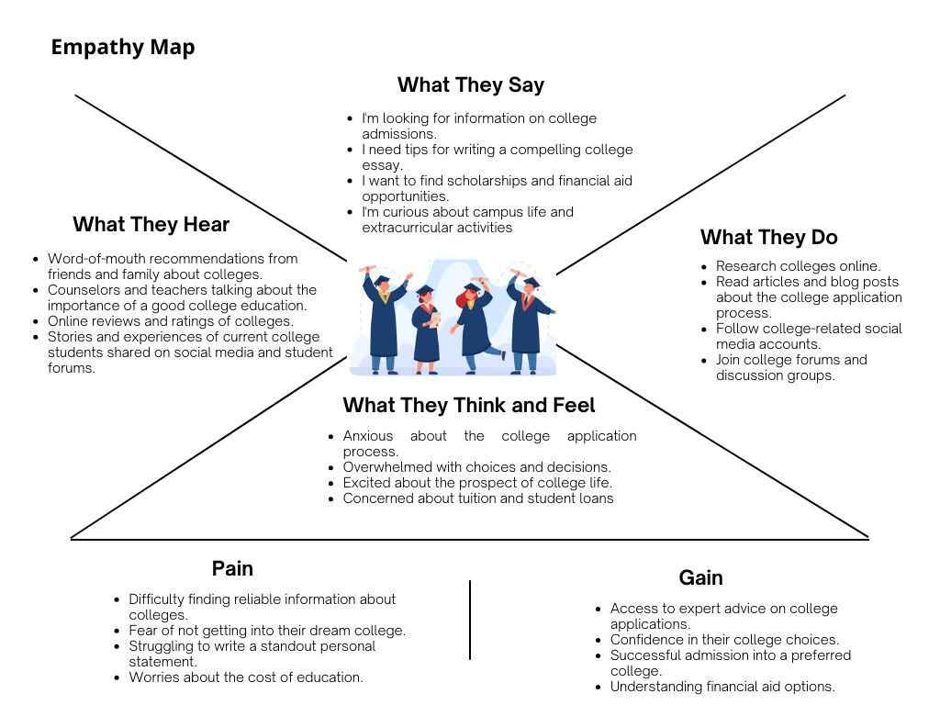The empathy map highlights the needs, pains, gains, and feelings of the target audience, helping to understand user perspectives.

**2.2 Ideation & Brainstorming Map**

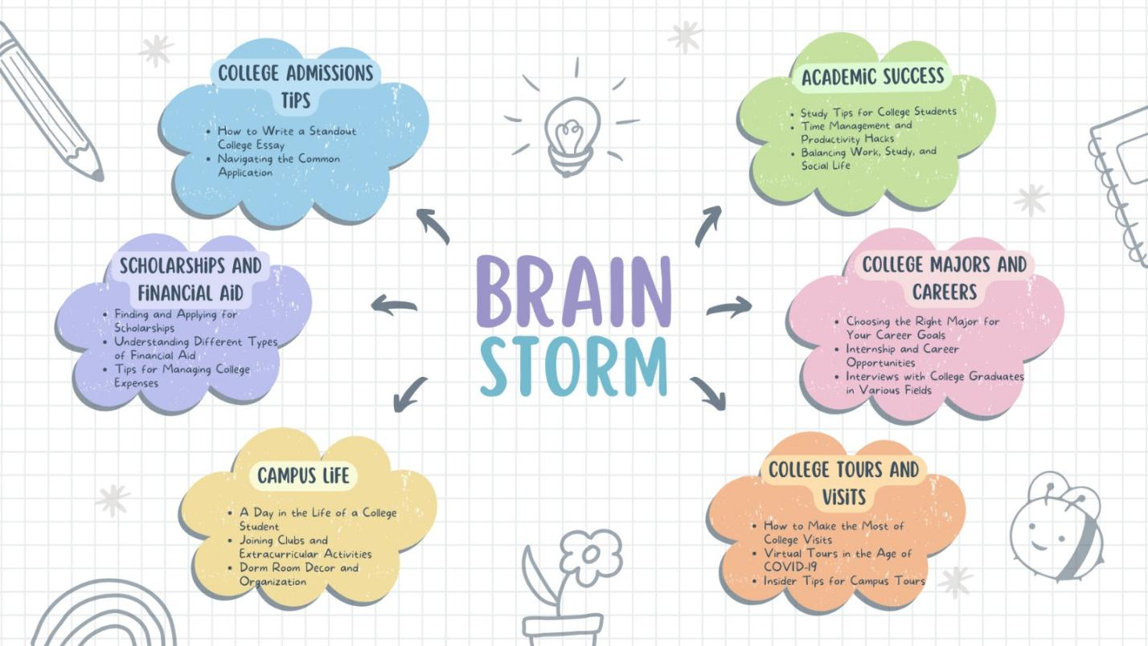

This map illustrates the creative process and brainstorming that guided the project's design and feature selection.

**RESULT**

The final findings of the Website Project include:

* A fully functional, responsive, and visually appealing website.
* Seamless user navigation and engagement features.
* Customized theme that aligns with the project's objectives.
* Effective configuration of essential plugins.
* SEO optimization for improved search engine visibility.

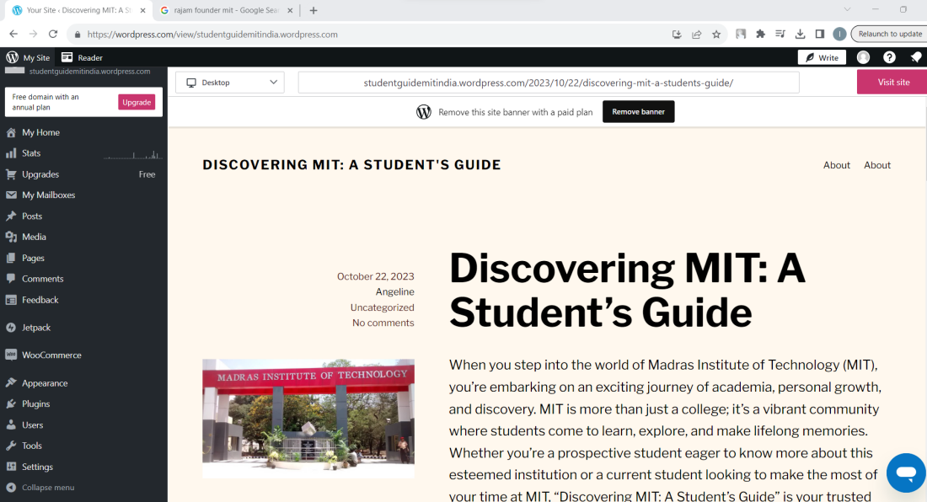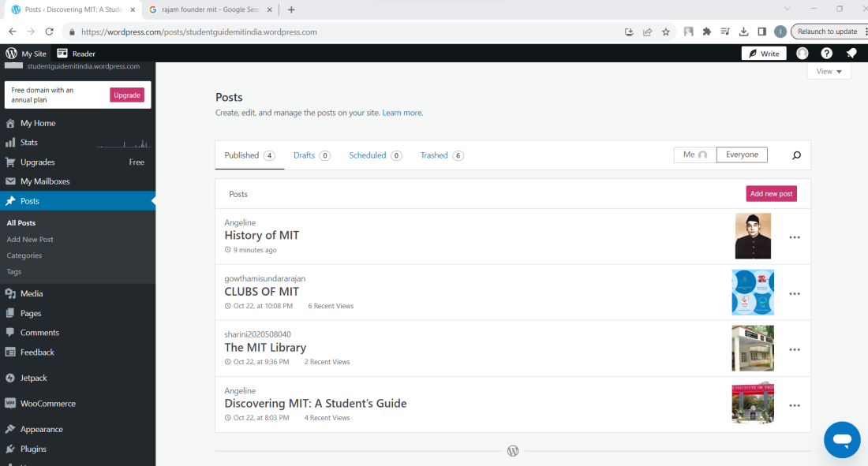

**ADVANTAGES & DISADVANTAGES**

Advantages:

* User-friendly design and layout.
* Enhanced user engagement.
* Improved search engine visibility.
* Efficient content management.

Disadvantages:

* Maintenance may be required to keep the website up to date.
* Initial setup and customization effort.

**APPLICATIONS**

The Student Page MIT Website can be applied in various contexts, including:

* Providing information about mit.
* Engaging with students and prospective students.
* Establishing an online presence for the college.

**CONCLUSION**

In conclusion, the Project has successfully achieved its goals of creating a dynamic and user-friendly website. The website is responsive, visually appealing, and optimized for both users and search engines. It serves as an effective platform for sharing valuable information, engaging with the audience, and establishing a strong online presence.

**FUTURE SCOPE**

Future enhancements for the website may include the addition of more interactive features, regular content updates, and further SEO improvements to expand its reach.